DIS-AM,C-Yaino-Cemi-Cohoba Inhaler

The inhaler is made from the end of a vertebrae probably a young manatee. The two large eyes suggest subject is an owl. The mouth is the cohoba receptacle connected at the chin by a short drilled tube. Width 7.1cm or 2.8". Originally from the Dominican Republic. Dating c 1000-1500AD

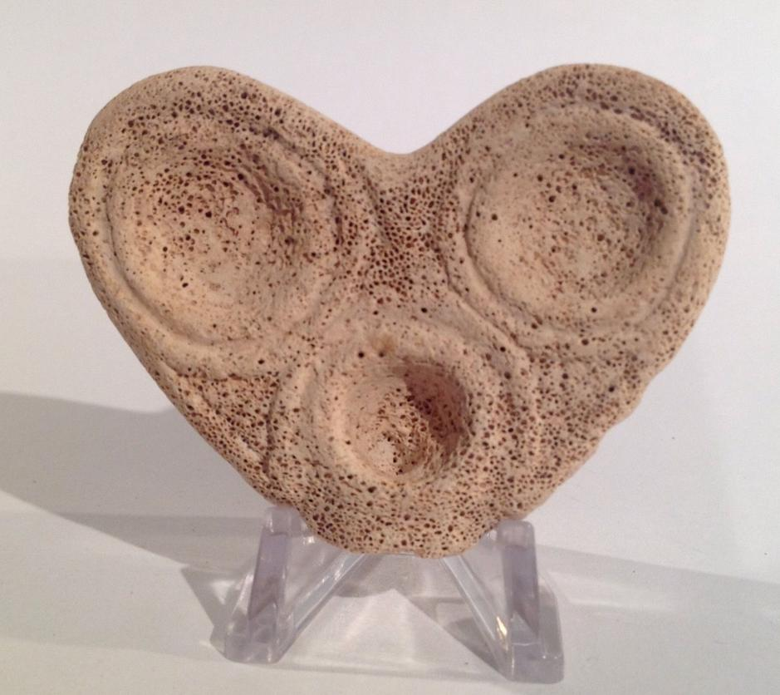 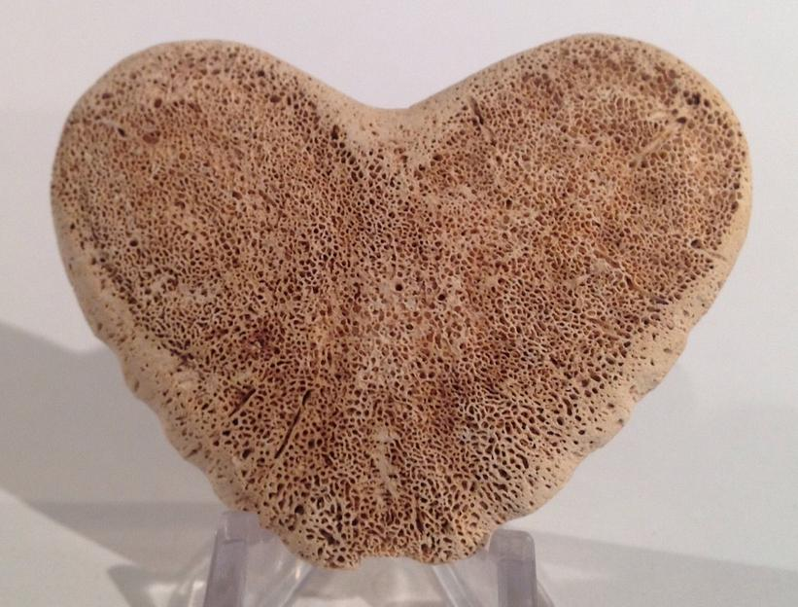 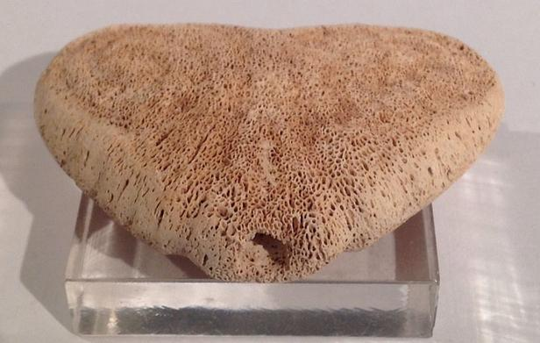

|  |  |
| --- | --- |
| ORDER DATEMar 26, 2016 | ORDER TOTAL  US $112.50  + US $7.00  shipping  **Order Taino Owl Face Cohoba Hallucinogenic Inhaler pre-Columbian** [Leave feedback - ORDER DATE Mar 26, 2016](http://feedback.ebay.com/ws/eBayISAPI.dll?LeaveFeedbackShow&useridto=flapast&transactID=0&item=262339688374&_trksid=p2057872.m2749.l2665)[View order details](http://payments.ebay.com/ws/eBayISAPI.dll?ViewPaymentStatus&transId=0&itemid=262339688374&_trksid=p2057872.m2749.l2673) - ORDER DATE Mar 26, 2016  [More actions - ORDER DATE Mar 26, 2016](http://www.ebay.com/myb/PurchaseHistory) |

1 item sold by [flapast](http://www.ebay.com/usr/flapast?_trksid=p2057872.m2749.l2754)

|  |
| --- |
| [Taino Owl Face Cohoba Hallucinogenic Inhaler pre-Columbian](http://www.ebay.com/itm/262339688374?_trksid=p2057872.m2749.l2649&ssPageName=STRK%3AMEBIDX%3AIT)  ( 262339688374 )  Delivered on Wed, Mar 30  Tracking number: [**Tracking number**9400109699938335806790](javascript:;) |